Assgniment

----- emp, dept,

system login

1. location -> lid -> pk, city, gen values using sequence, insert data

2. alter dept-> lid -> relate dept location, add corresponding entries

user login

--> join-> 3 table

firstname from employee which dept-> deptname, city of employee

--> print empl-> id firstname, having highest salary

having second highest salary

create table location(

lid NUMBER(8) constraint location_pk primary key,

city varchar2(20)

);

create sequence assi_loc_genpk

start with 1000

increment by 10

nomaxvalue

NOCYCLE

CACHE 10;

insert into location values(assi_loc_genpk.nextval,'kolkata');

insert into location values(assi_loc_genpk.nextval,'mumbai');

insert into location values(assi_loc_genpk.nextval,'delhi');

insert into location values(assi_loc_genpk.nextval,'hydrabad');

select * from location;

alter table department add lid number(8);

update department set lid = 1000 where deptid = 999;

update department set lid = 1010 where deptid = 888;

update department set lid = 1020 where deptid = 777;

grant select,insert,update,delete on EMPLOYEE to may13;

grant select,insert,update,delete on DEPARTMENT to may13;

grant select,insert,update,delete on LOCATION to may13;

--may13

select e.firstname, d.deptname, l.city from

SYSTEM.employee e natural join SYSTEM.department d

natural join SYSTEM.location l;

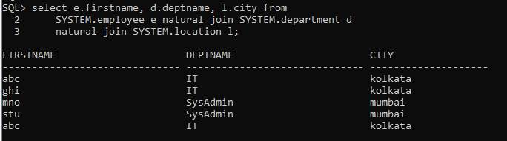

select empid,firstname,salary from employee

where salary = (select min(salary) from

(select distinct salary from employee order by salary desc)

where rownum < 3);

